Individual Report

Collaborative Software (Liam)

Remigija Vindasiute (x17432284)

# Introduction

In this report I will explain the advantages and challenges of collaborative software, and the cost and benefits of using it. I have chosen Airtable collaborative software as one that I believe suits the needs of MCTV limited the best. In this report I will also investigate three alternate collaborative software’s and compare them to Airtable. Finally, I will include a user guide on using Airtable and explain why I think investing in collaborative software is more important than in the software’s investigated by other family members.

# Advantages

There are many benefits of using collaborative software that can result in quicker and more efficient completion of tasks. Some of these reasons include:

* Time Saving – Using collaborative software can save a lot of time, as you don’t have to use e-mails or meet your team members to update them on your project progress. Everything that you do for a project will be visible to other team members through the collaborative software. This will result in better and faster communication between team members and work done quicker.
* Improved Project Management – Managing and keeping track of the team, its progress on the project and the progress of each individual can become quite difficult and time-consuming at times. However, with the use of a collaborative software this task becomes easier than ever – with just a quick look it is possible to see the overall and individual progresses of tasks.
* Stronger Team Relationships – Using collaborative software can also strengthen teamwork between team members, as they are not only working in a team, they are also working efficiently towards a set goal. With the use of collaborative software, the miscommunication between team members would be minimal, as everyone would be able to see who is doing what tasks and their progress on them.
* Improved Organisation – With the use of collaborative software it also becomes easier to keep track of tasks that are done, and those that are not yet complete. This would help with the overall efficiency of a team, and the business in general, as the tasks and files would be perfectly coordinated and organised.

# Challenges

There are also some challenges that come with using collaborative software. Here are some of them:

* Cost – Collaborative software can be quite expensive, especially looking at the cost for it on yearly or even longer basis. Many collaborative software’s, including Airtable, have different packages for different needs, and the price increases as the package goes up in quality.
* Security – No cloud-based software is completely safe from hackings, so security of information is one of the disadvantages of collaborative software. Even though we don’t handle any sensitive information in MCTV Limited, protecting the personal information of our customers is still important. This challenge can always be overcome with the use of third-party security providers.

# Cost and Benefits

There are a few pricing plans that can be chosen for Airtable. These plans include a Free account, a Plus account and a Pro account. Each of these comes with different prices and the higher priced plans offer more features.

In my opinion, the Plus account plan would best suit our interests, as our company is relatively small and does not require a Pro account yet. The Plus account costs around $10 per month per user, if paid annually. This plan allows to have an unlimited number of databases, while the number of records per database is limited to 5000. The storage space of this plan is 5GB, and you also get 6 months of revision and snapshot history.

I believe that the Airtable Plus plan would be perfect for our company, as it has less limitations compared to the free version, but the price is still in our financial range. The features offered are also enough for a company of our size, so getting a Pro plan would be unnecessary.

# Competition

The competition for Airtable I’ve investigated include: Trello, Asana and Zoho Projects. Out of all of these software’s, Airtable is the easiest to use. It has many features but is still very intuitive in terms of usage. While Zoho Projects have better customer support and more features than Airtable, it also has a monthly price that is higher($25). Airtable is also the most flexible out of all the other software’s I’ve investigated. You can apply and use Airtable almost for anything.

Unlike Trello, Airtable is way easier to use, and it supports many more project views, meanwhile Trello only has Kanban board view. Airtable not only has the Kanban view, it also has a grid and calendar view and many more.

Overall, despite not being an ideal software, Airtable is easy to use, flexible and the most user-friendly out of all the other software’s I’ve investigated. I believe that this alone is a huge advantage, as no one in our family is very technology literate

# User Guide

To get started with Airtable, you should go to the website [www.airtable.com](http://www.airtable.com) and make an account through there. The steps to making an account are simple and easy to follow.

For the user guide, I have decided to write and show a step by step process on creating and customising a base using a template on airtable. A base in the airtable is basically a single database, that contains all the information you need for a project or interest. A base can be created through a template, or completely from scratch.

## Creating and Customising a Base (From Template)

STEP1: When you first log in to your Airtable account, you will see this screen: 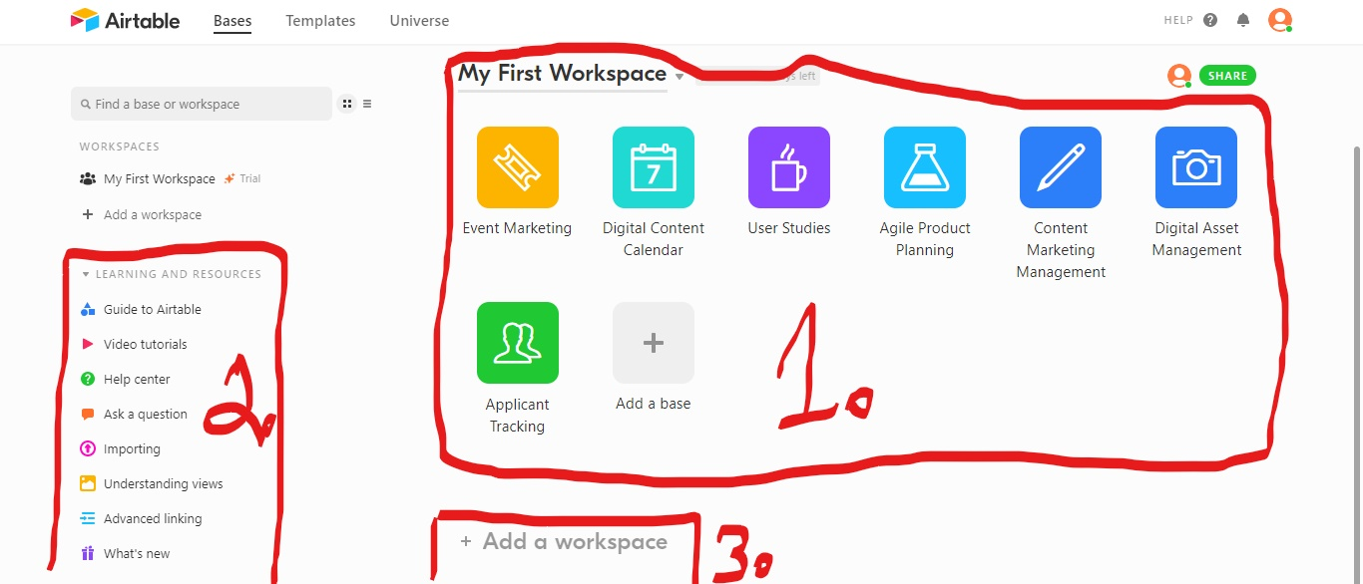

At number 1 you can see your first workspace, with a few sample bases. These bases can be explored to better understand how a base is created, and how it can be used.

At number 2, there are many useful links provided. These links include tutorials and guides on using and understanding airtable.

Number 3 shows you the place where you can create a new workspace with only one click.

STEP 2: Now that you are familiar with the very first screen that shows up when you log in, let’s move to making the base. First, take a look at this picture: 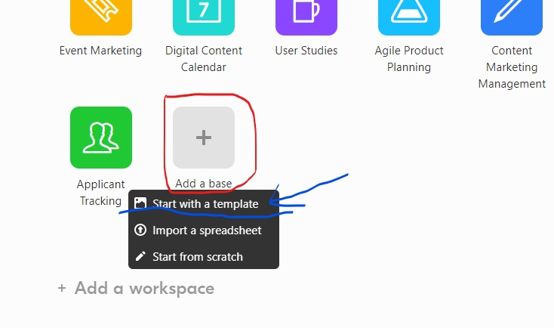

In this picture, the red outline shows you where to click to make a new base. After you click on the “Add a base” option, you will be given a choice to create the base using a template, importing from spreadsheet, or starting from scratch. To create a base from a template, please click the “Start with a template” option, as shown by the blue arrow.

STEP 3: After clicking on “Start with a template” option, you will be brought to this screen: 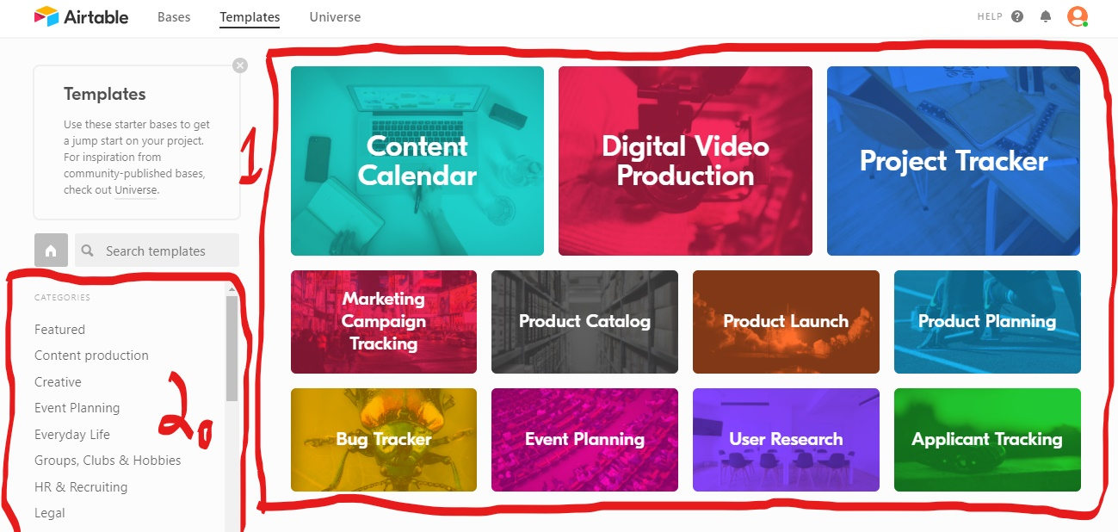

In this picture, at number 1, you can see various templates to choose from. If you scroll down, even more templates will show up. At number 2, there is a category list, so if you have an idea for what the template will be used for, you can quicken your search by using these categories.

For the sake of this user guide, I will be using the “Project Tracker” template. After clicking on the template you chose, you will see this screen: 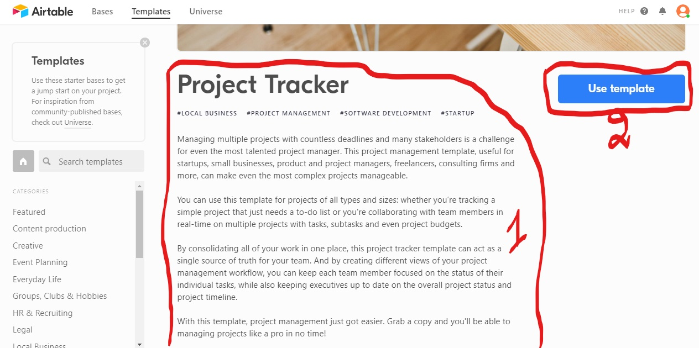

At number 1, you can see the description of the template, while clicking on the button at number 2 will use the template you chose for the base. After clicking on the “Use Template” button, you will be brought back to your workspace.

STEP 4: When you are back in your workspace, you’ll be able to see the new base in there: 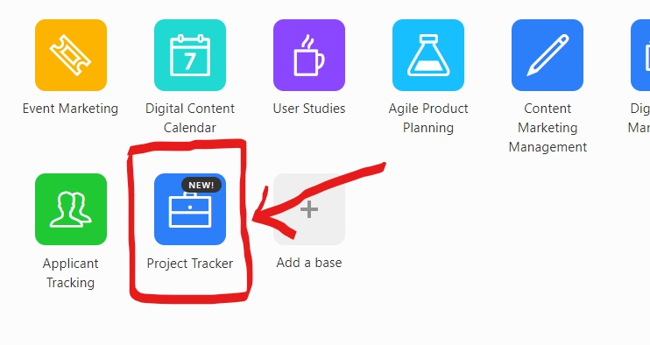

Clicking on the drop-down arrow at the bottom of the base will allow you to customise the base. At number 1 you can choose the colour of your base.

At number 2, you can choose an icon for your base.

At number 3, you can change the name of your base.

Number 4 allows you to share the base with others. In other words, add collaborators to the base.

Number 5 allows you to delete a base if it is not needed.

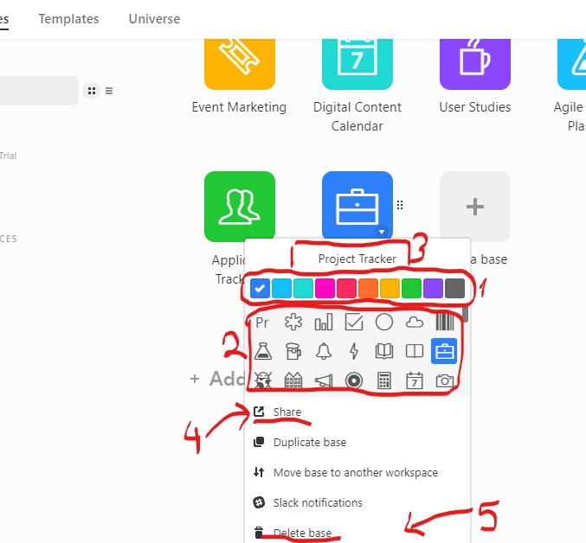

STEP 5: Clicking on the base will bring you inside of it. Every template comes with sample tables and data inside, so that the base is easier to understand. This sample data and tables can be easily changed to your own needs, using the data you have. 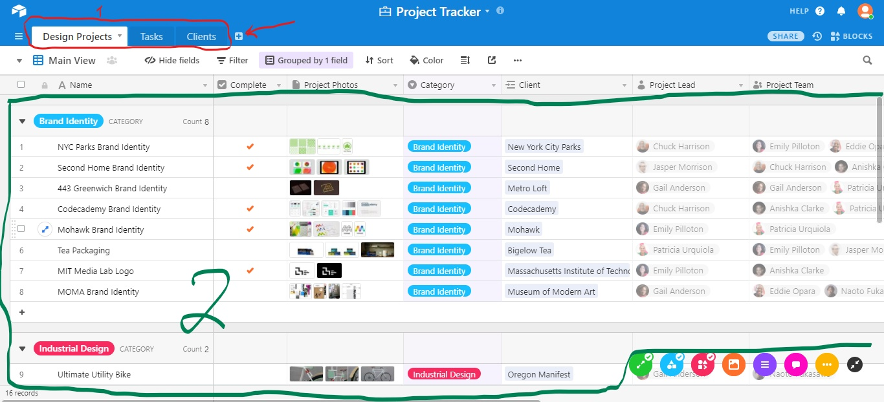

At number 1 you can see all the tables in the base. You can see each table by clicking on it. To create a new table, just click the plus sign next to the tables (Red arrow). At number 2, you can see all the records and information attached to the records.

STEP 6: There are many functions for navigating through and fully utilising your base. Some of these include: 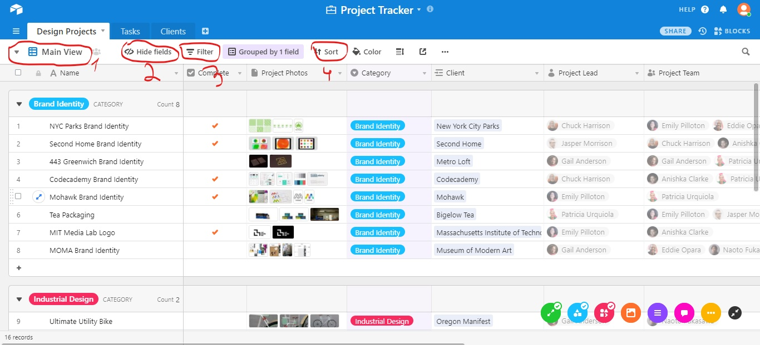

Switching the display of the base (at number1). For example, looking at records on a calendar view.

Choosing which fields should be visible (at number 2).

Filtering the records by some criteria of your choosing (at number 3).

Sorting the records (at number 4).

STEP 7: You can also add more records and fields of your choosing to the base. 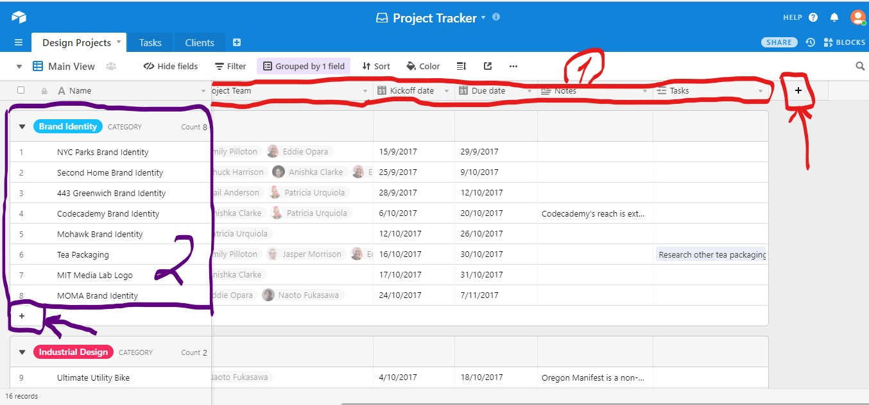

At number 1, you can see the fields that are already in the base. If you click a plus sign (red arrow) next to them, you can create a new field.

At number 2, you can see the records in this base. By clicking a plus next to them (purple arrow), you can add more records.

STEP 8: You can also expand a record to see all the information related to it, to add attachments, see revision history, add comments and do many more things. 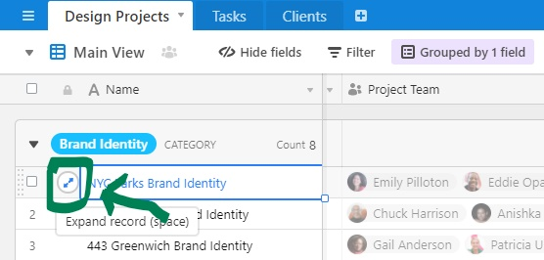

To expand a record, click the box shown in the picture. After clicking it, you will see this screen: 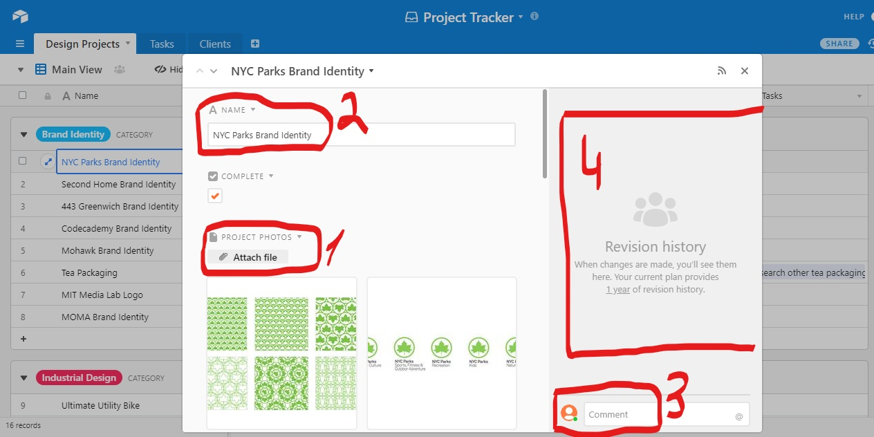

At number 1, you can attach files. Number 2 allows you to change the name of the record. Number 3 is where you put in your comments related to the record. At number 4 you will be able to see the revision history, in other words, the changes that were made to the record. By scrolling down, you will also be able to see all of the information already added to the record, and even add any extra information that you feel is important.

This was my user guide on creating and customising a base from a template which, I hope, will help you to create your own base and to start using it.

# why this is important

I believe that investing in collaborative software is more important than in software’s suggested by other family members, because working as a close team and cooperating effectively on all the tasks would help us to improve the company a lot and help us to achieve a better customer service.

I believe that creating a better website at this point is unnecessary – we already have a website, even if it’s only basic, so we should concentrate on first improving the areas that need improving.

Moving into an integrated accounts package, as suggested by Roberta, is also not very urgent. Airtable is not only a collaborative software, but also functions as a database. Therefore, the files in the excel sheets can be easily transferred to the Airtable, which would make organising information and collaborating even easier.

Also, as Derek said that “the functioning need for any business should be driven by customer relationships”, and I believe that using Airtable to collaborate on various tasks and projects in the company would allow us to do that. Using collaborative software would increase our efficiency, therefore making customer service and their satisfaction with the company higher.

In conclusion, I strongly believe that we should incorporate Airtable in our company, instead of software’s suggested by other family members.